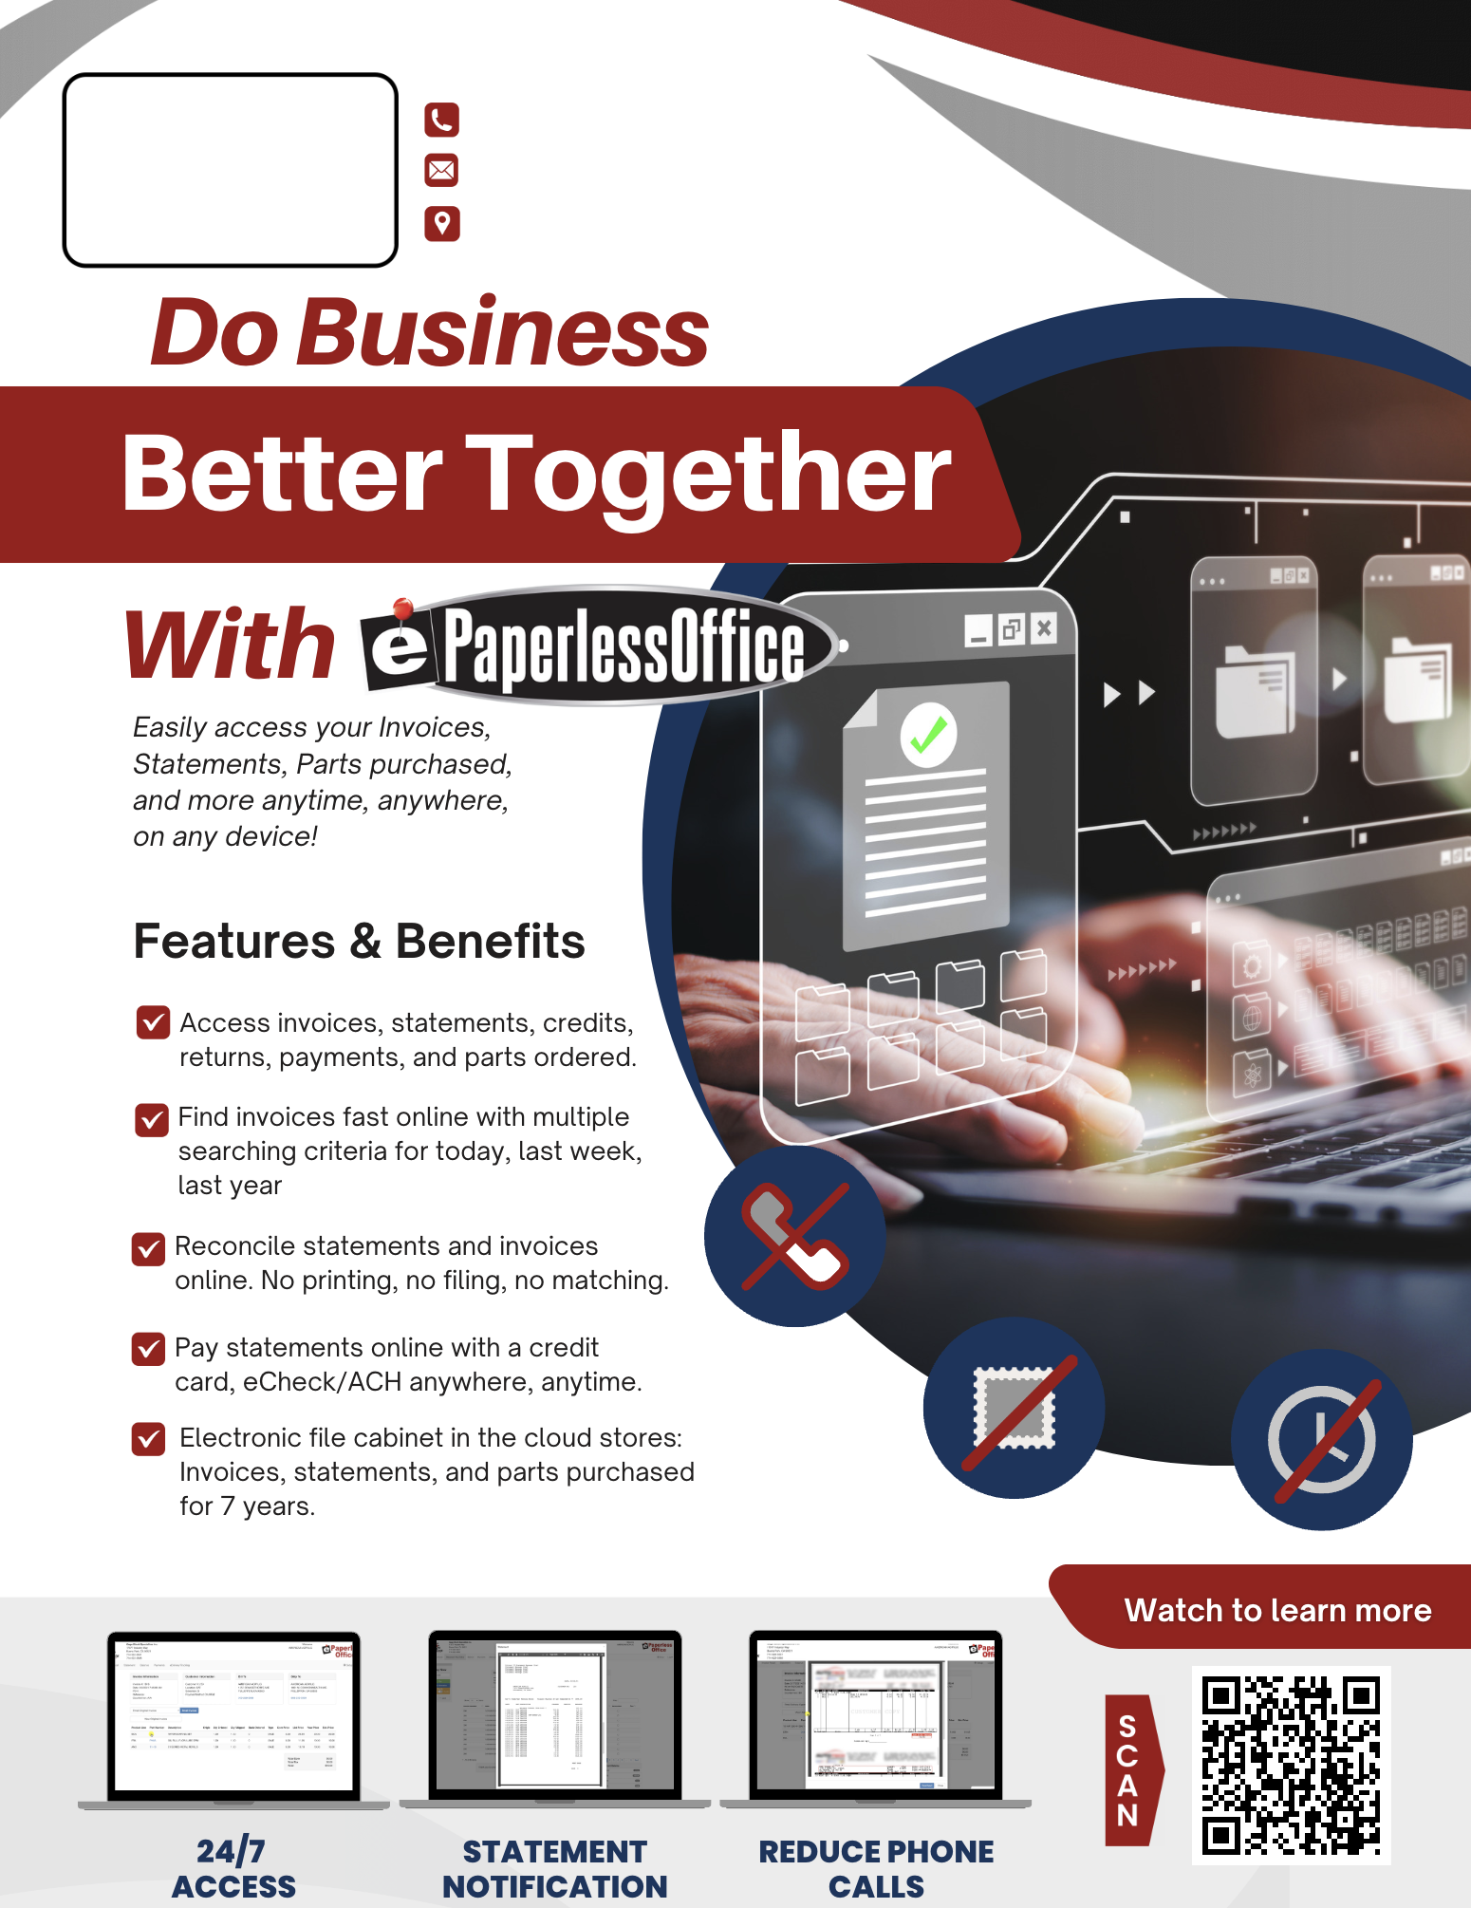

**YOUR**

**LOGO**

**HERE**

hello@mywebsite.com

123 Anywhere St., Any City

888-888-8888